**Search Layer and Generation Layer Screenshots –**

**Query 1 -**

**Answer from Search Layer**

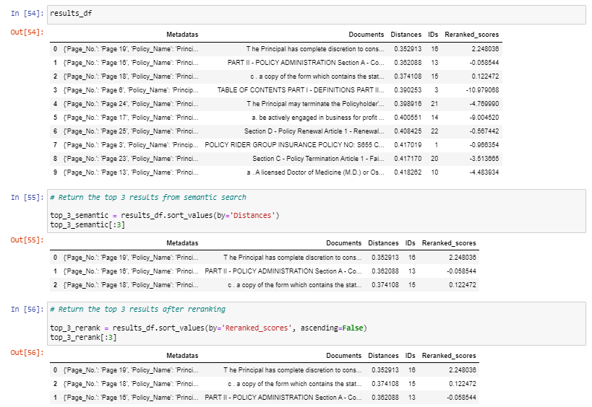

**Answer from Generation Layer**

**Query 2 –**

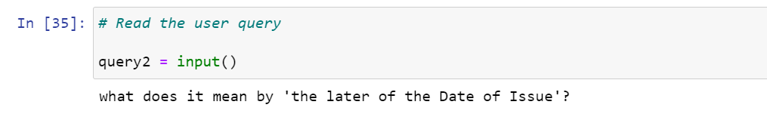

**Answer from Search Layer**

**Answer from Generation Layer**

**Query 3 –**

**Answer from Search Layer**

**Answer from Generation Layer**

